ICT710 – Interaction Design and Usability
Assessment 3

Preethi Edukulla (66993)
Saikiran Bitla (66158)
Varshini Koyyalamudi (65079)
Rasagna Karingula (65411)
Ravichandra Atthuluri (64812)
Table of Contents
1. Introduction 3
2. Design Process 3
3. Design Rationale 4
4. User interface design 6
5. Usability Evaluation 21
6. Conclusion 23
7. References 24

Introduction
The online mobile trading application is developed to allows the users to manage stock and crypto transaction easily. The application having a options to search for financial assets, purchase and sell stock, transfer money from one bank account to another, utilize auto trading features and access support via chatbot system. The project was designed to address the future requirement based on needs analysis and usability evaluation report. The objective of this online mobile trading application is to develop an effective interface to enhance the efficiency of trading, minimize user confusion and facilitates secure financial transactions.
The audience of the application are young adults, students in universities and working people with good experience in mobile phone for regular financial transactions. The design process was focus on simplicity, accessibility and easy navigation. Because this developed trading applications demand swift decision-making and precise interaction. The application is need to enhance user satisfaction by ensuring modern interface and meets user expectations and usability standards in future.

Design Process
Requirement Analysis
The design of mobile trading application started with analysing the findings collected from the previous needs analysis and usability testing report. The conducted data and requirement analysis revealed that customer needs a simple, fast, secure trading application. Because the advanced functions like auto trading and bank transfer options are difficult to access for many participants. Users also wanted the improvements in navigation, easy to understand icons and quick access to key trading tools. These analysis report help the design team to understand the expectation of user and then start the interface development.
Planning and Wireframing
After the requirements of users are identified then need to create the plan for structure of the application and develop the required wireframes. Basic layouts are created to structure the key features of the application like dashboard, stock search page, buy and sell, bank transfer page, auto trading settings and chatbot support [1]. The wireframes highlighted the location of important functions to avoid confusion of users. Simple navigation paths also planned to enable the user to do the required action quickly. This stage was useful to understand the flow of the application before final design screens development.
User Interface Design
Figma is a tool used to complete the user interface design for online trading application with collaborative design. The developed interface is designed in a modern style, featuring simple color, simple fonts and clear icons to enhance user experience. The home dashboard was having an important function like buying, selling and searching. All the developed screens are having the same spacing and button layouts to make the experience more organised for the user.
Prototype Development and Feedback
The quality prototype was created in Figma to simulate real user interactions. The prototype enabled the users to explore the various parts of the application and complete typical trading operations [2]. Group members provided feedback throughout the review process and test users provided feedback at the end. Feedback was used to make several changes such as making navigation icons bigger, making the menu titles more readable and improving the visibility of the chatbot. The step-by-step design process allow the developers to continuous improvement of the application.

Design Rationale
Simplicity and minimalism
Justification
The smart trading app design rationale is based on usability principles, mobile trading system research and user feedback collected during the needs in analysis stages.
Evidence
The main objectives of the redesign are to creating a trading platform that is secure, safe and efficient for both beginners and experience traders [3].
Innovative solution
There are two main design tenets used for the minimalism and simplicity then the users may become overwhelmed by the extensive financial information found in trading programs.

User-centered design
Justification
The interface was modified with simple layouts, well-organized options and few visual distractions to lessen cognitive burden and increase task efficiency.
Evidence
By using mobile trading app, the trading systems should prioritize completing activities swiftly with the fewest clicks possible and responding promptly to changes in the market. It is easy to navigate and increasing the usability.
Innovative solution
In this application have to create a structure that makes simple for the users to reach the important features that include the dashboard, markets, notification, watch list, trade, and settings.
Navigation and accessibility
Justification
In this analysis have the strong visual hierarchy and simple navigation that enhance usability and enable users to rapidly recognize crucial actions.
Evidence
It is easy to finding the information that including stock prices, values, and buy/sell buttons. The staff were increasing familiarity and reduce user confusion, standardized button styles, colors, icons, and typography [4].
Innovative solution
The users can learn the system more quickly and confident when conducting payment transactions because of design patterns are consistent.
Security and trust
Justification
The security and trust were important factors to take into account because the users conduct sensitive financial activities within the program.
Evidence
The features like login, two-factor authentication, transaction confirmation screens, and notification alerts were included that will increasing the user confidence and account security. Innovative solution
It will be maintaining the user confidence in financial applications requires safe authentication procedures and transparent transaction flows [5].
Innovative features
Justification
The smart trading app incorporated with advanced features including auto-trading capabilities and AI chatbot help to increase accessibility and productivity.
Evidence
The chatbot provides consumers immediate support, trading advice, and troubleshooting aid. Innovative solution
The auto trading features have low manual labor and facilitate technical trading activities with automating trading methods based on predetermined criteria. So, these tools make trading more intelligent and increase user engagement.

User interface design
The Trading user design interface is designed with a user-friendly and modern layout which used to support a smooth navigation, accessibility and visual clarity [6]. An organized sections, consistent colors, interactive components and intuitive buttons were implemented to improve usability, enhance experiences of the users and simplify trading operations.


Figure 1 - Welcome Screen

Welcome screen introduces Trading application with a modern interface and it directs users towards accessing the application using the registration.
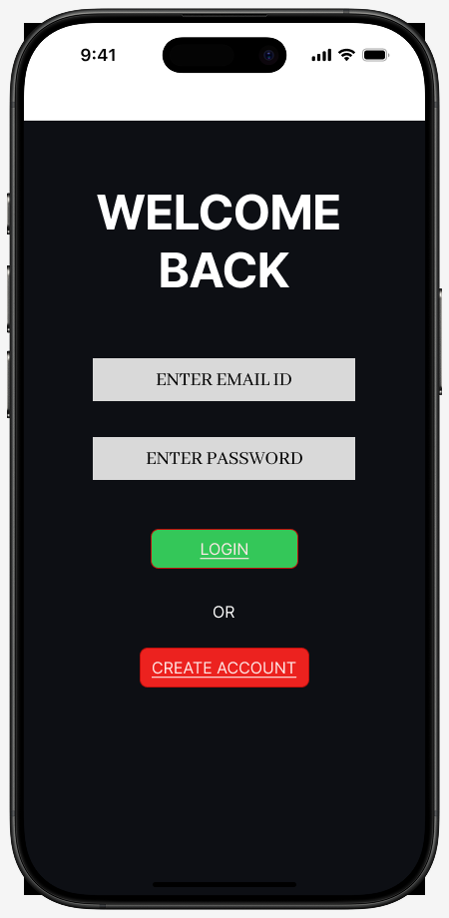
Figure 2 - Login Screen

The login screen allows the users to access their accounts in a secure way through email credentials with a simple authentication and navigation features.

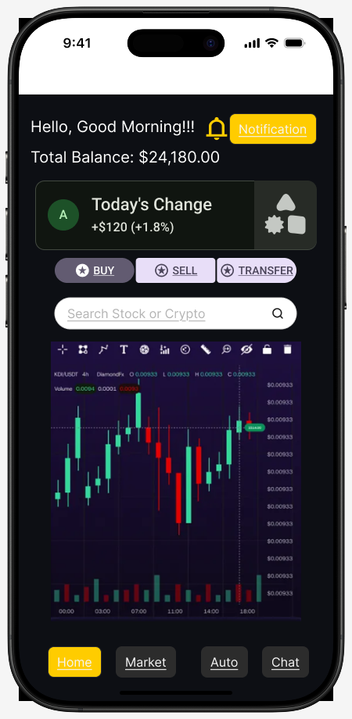
Figure 3 - Home Dashboard Screen

The dashboard screen helps in displaying trading actions, account balance, market updates and a quick navigation to an important application services and features.

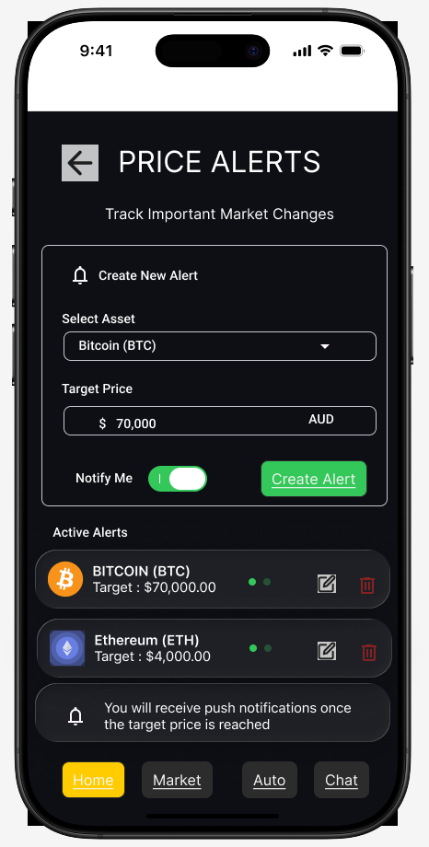
Figure 4 - Price Alert Notification Screen

The price alert screen shows that it enables users to create notifications for a selected assets when a target market price are reached successfully.

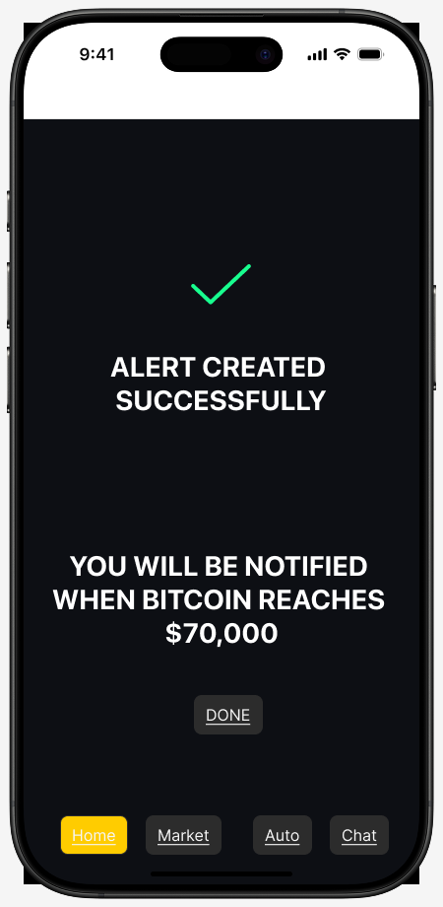
Figure 5 - Alert Successful Screen
The alert successful screen helps to conform in which the price alert was created and it assures the users regarding the future trading updates and notifications.
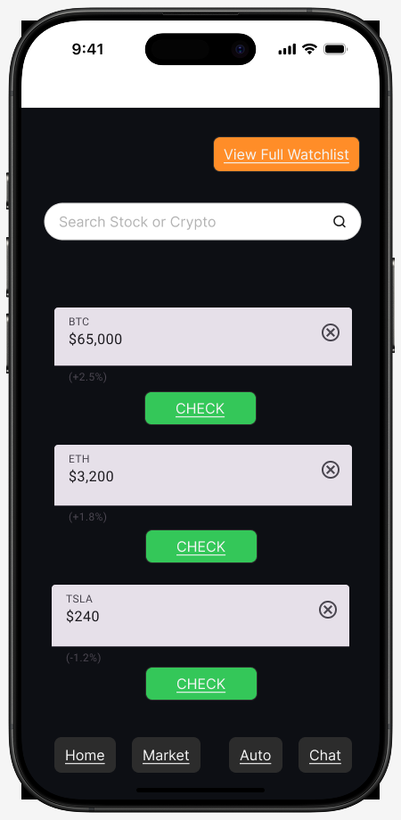
Figure 6 - Search Screen

The search screen helps in displaying the available cryptocurrencies and stocks with the percentage changes, current price and also a quick buy or sell options.
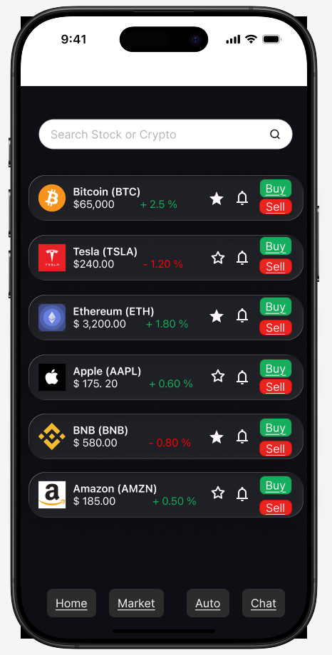
Figure 7 - Watchlist Screen
The watchlist screen allows the users to monitor their favorite stocks or cryptocurrencies in a very quick way without any repeated search in the market assets with manual search [7].
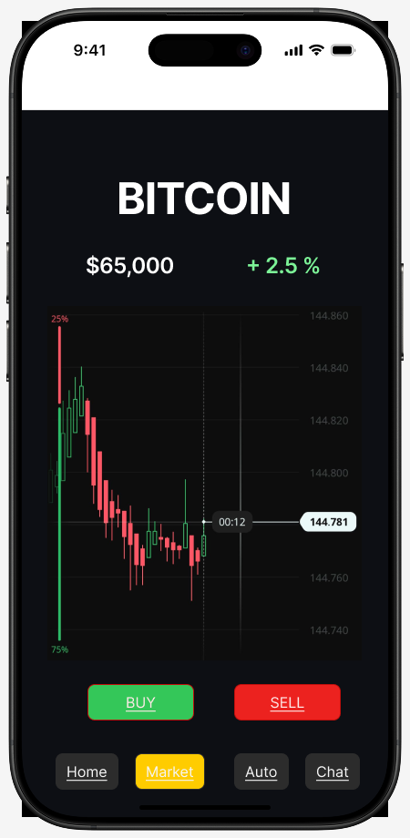
Figure 8 - Stock Details Screen

The stock details screen helps in giving a detailed information based on the selected cryptocurrency performance which is with a direct access to the selling and buying features.

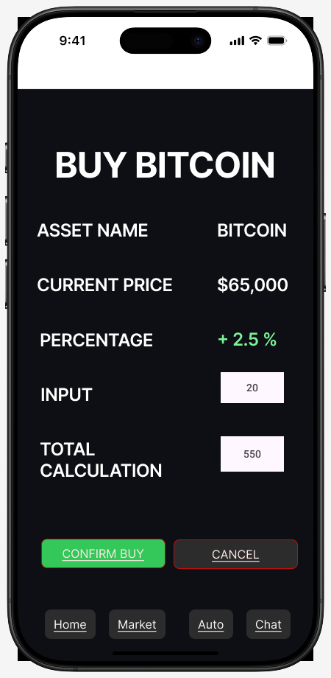
Figure 9 - Buy Screen
Buy screen enables users to purchase with a selected assets by entering the quantities and review with the transaction calculation before the confirmation of the processes.

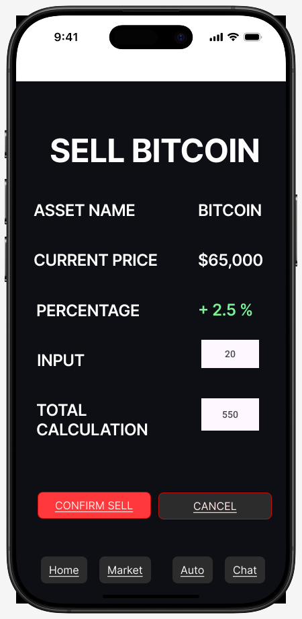
Figure 10 - Sell Screen

The sell screen allows the users to sell their owned assets by entering with quantities and confirm with the transaction details using a simple interaction.
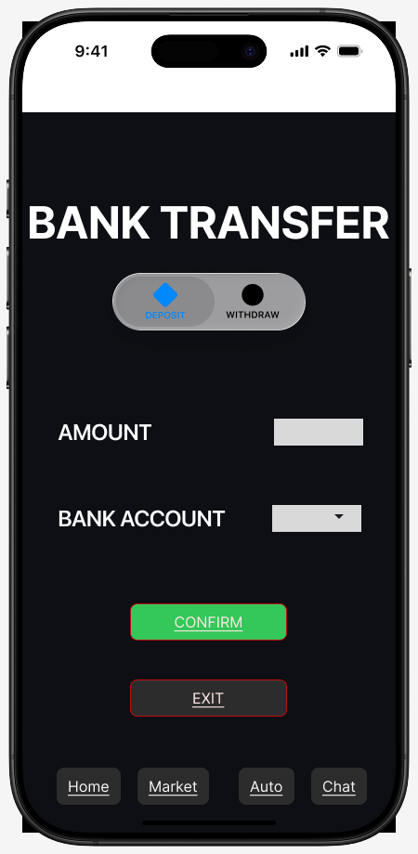
Figure 11 - Bank Transfer Screen
The bank transfer screen helps in supporting a secure deposit and a withdrawal function with an account input detail and included with a transaction conformation feature.

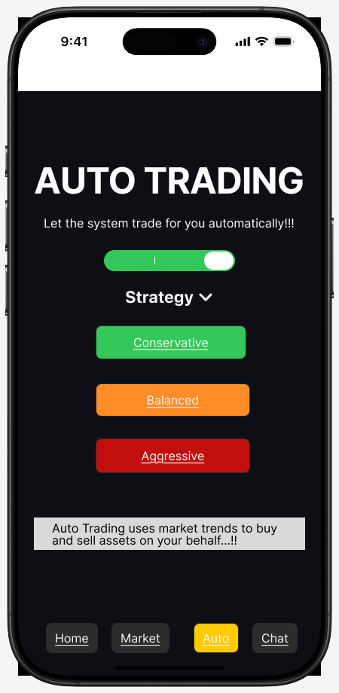
Figure 12 - Auto Trading Screen
The auto trading screen allows the users to activate with a automated trading strategies according to the selected risk preferences and market conditions.
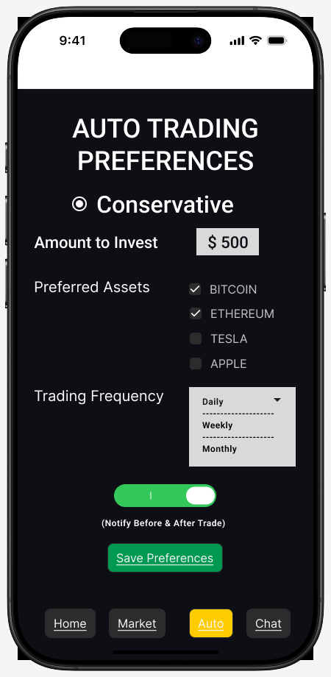
Figure 13 - Auto Trading Preferences Screen
The users are enabled in the preferences screen to customize investment amounts, trading frequency, preferred assets and notification settings for the automated features.
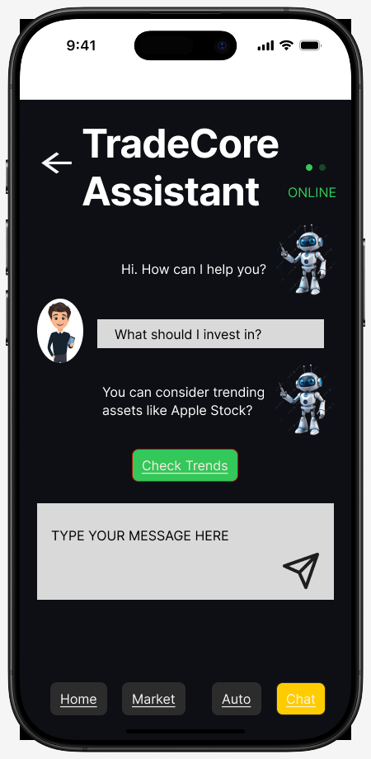
Figure 14 - Chatbot Assistance
Finally, the chatbot screen gives users investment guidance, instant assistance, and user support using an interactive messaging and a predefined response suggestion.

Usability Evaluation
Usability evaluation for the Trading Application is conducted using rigorous usability testing which is involved with many user tasks and survey-based feedback collection. Evaluation of participants are in navigation, responsiveness, interface clarity, and feature accessibility. This analysis helps in identifying strength like organized layouts, simple navigation and efficient task completion. The minor usability concerns are included with an improved transaction feedback and enhancement of chatbot responses.
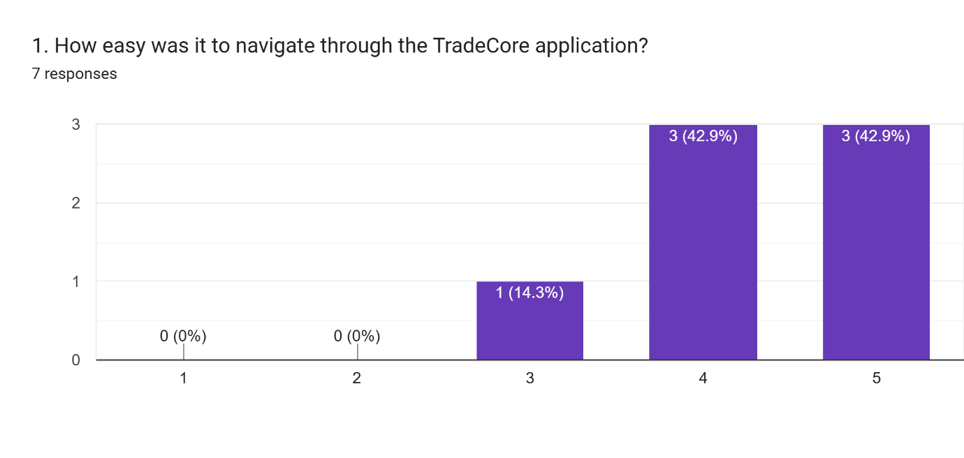
The image shows most of users found Trading application to be useful in navigation, and it is with an average usability of 4.3 out of 5.
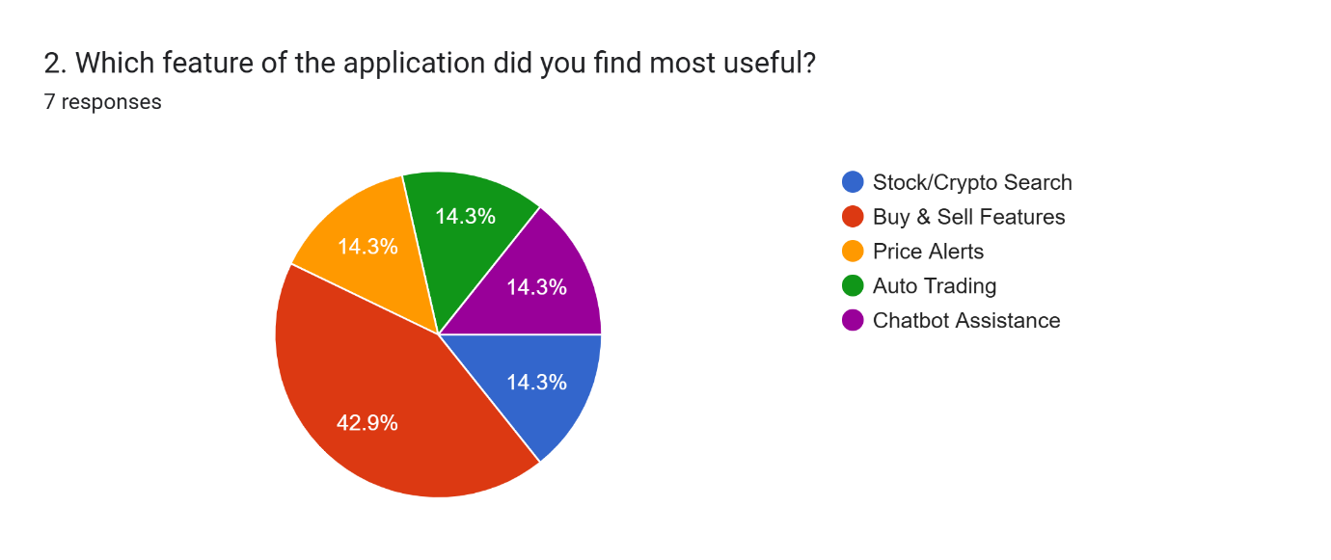
The most useful functionality to be identified here is the Buy & Sell feature that has the majority of the participants [8].
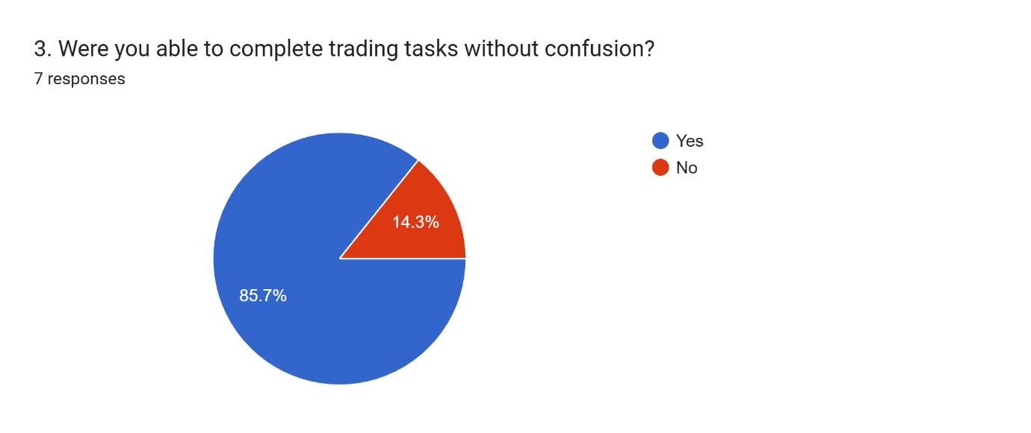
Around 86% of the users were able to use and complete the tasks for trading in successful way without any confusions.
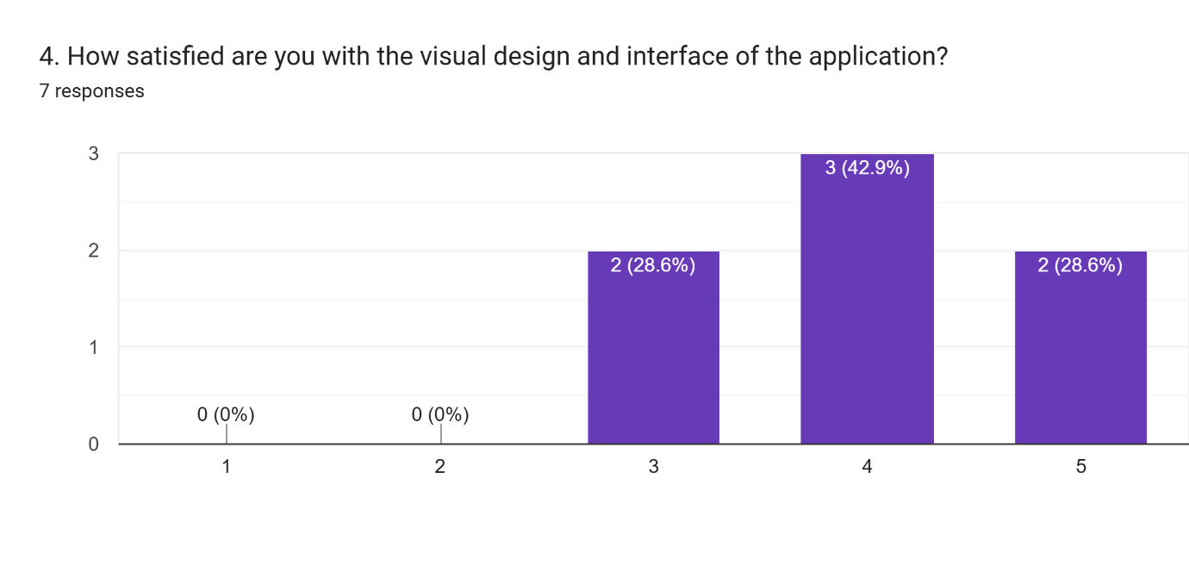
A positive satisfaction is expressed by users with a visual design in application which gives an average interface rating of 4 out of 5.
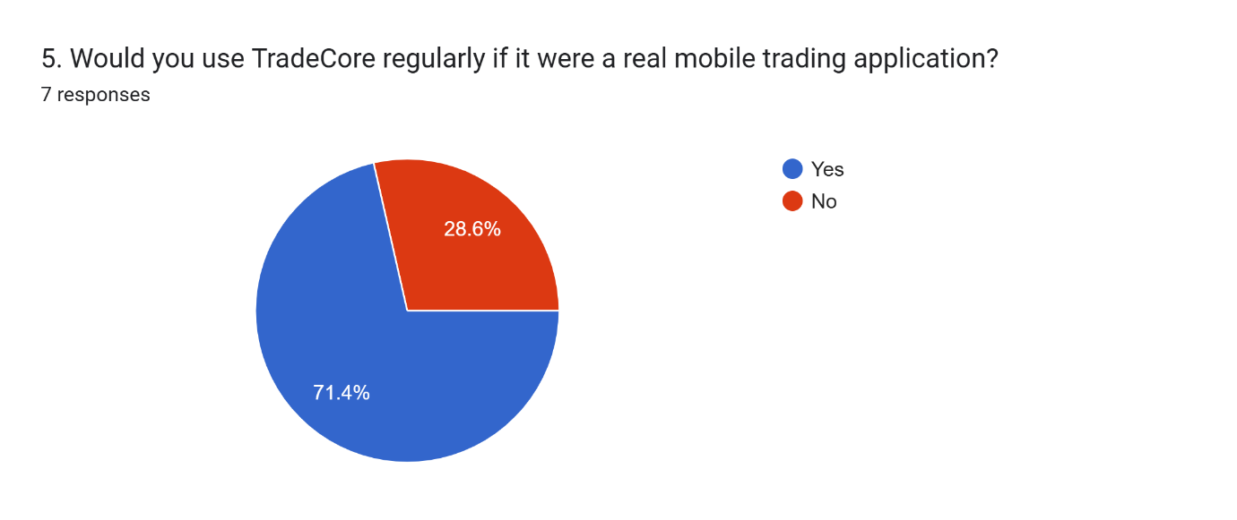
There an approximate of 71% of participants stated they will be using the Trading application regularly if they be developed as a real one.
According to the findings, actionable recommendations are proposed which includes improved notification systems, clear input guidance and enhanced personalized features that further used to improve usability performances and overall user experiences.

Conclusion
The smart trading app design project are used with usability and interaction design principles to enhance the mobile trading platforms usability and usefulness. The project are involved in navigation, accessibility, security, and transaction efficiency using usability testing, interface redesign, and user-centered design techniques. The updated program provides a more user-friendly and graphically consistent experience for both invoice and expert traders. The features include chatbot support, auto trading, portfolio management, and secure login that enhanced the user satisfaction and usefulness. The report showed that value of interface design is to created safe, usable, and effective mobile financial applications.

References

[1] | Z. Huang and M. Benyoucef, “An Empirical Study of Mobile Application Usability: A Unified Hierarchical Approach,” International Journal of Human–Computer Interaction, vol. 39, no. 13, pp. 2624-2643, 2021.
[2] | P. Weichbroth, “Usability of Mobile Applications: A Consolidated Model,” IEEE Access , vol. 12, pp. 62378 - 62391, 2024.
[3] | A. K. Srivastava, “Design a Real-Time Stock Trading Platform,” Medium, 14 June 2025. [Online]. Available: https://medium.com/@ankitviddya/design-a-real-time-stock-trading-platform-d4537cf5d0c7.
[4] | E. N., “Design quality of Mobile trading system application software for Smartphones,” Asian Journal of Management, vol. 7, no. 3, pp. 207-212, 201.
[5] | K. Rafalski, “Financial App Design: UX Strategies for High-Performance Mobile Trading,” netguru, 22 January 2026. [Online]. Available: https://www.netguru.com/blog/financial-app-design.
[6] | M. A. Faudzi, Z. C. Cob, M. Ghazali, R. Omar and S. A. Sharudin, “User interface design in mobile learning applications: Developing and evaluating a questionnaire for measuring learners' extraneous cognitive load,” Heliyon, vol. 10, no. 18, pp. 1-20, 2024.
[7] | M. Sandesara, M. D. Alshehri and M. S. Raboaca, “Design and Experience of Mobile Applications: A Pilot Survey,” Mathematics, vol. 10, no. 14, pp. 1-21, 2022.
[8] | A. Alzahrani, R. Alturki and V. Gay, “The Evaluation of the Usability in Mobile Applications,” Proceedings of the 40th International Business Information Management Association (IBIMA), pp. 56-69, 2022.

